***Object Oriented Programming Lab 7***

***Niranjan Dhokarikar 65***

***ME-A Batch 3***

**Problem Statement ->**

Implement a base class Shape. Use this class to store two double type variables that could be used to compute the area of the figures. Derive two specific class function get_data to initialize the base class members and another member function display_area to compute and display the area of the figures. Using these three classes to design a program that will compute the area for the triangle or the rectangle by taking user inputs.

First user input x = [ length for rectangle, base for triangle]

y = [ breadth for rectangle, height for triangle]

Code ->

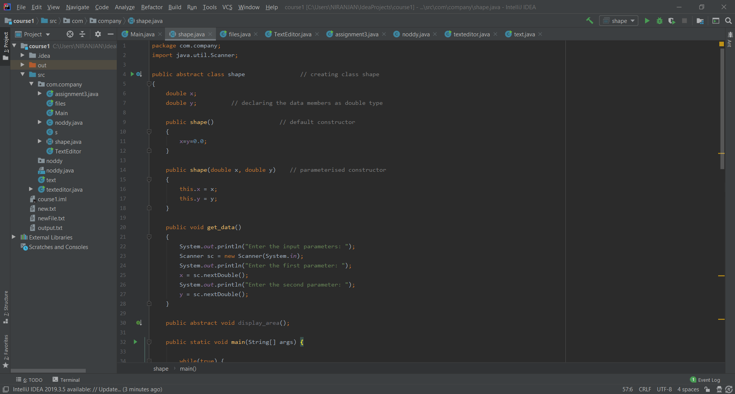

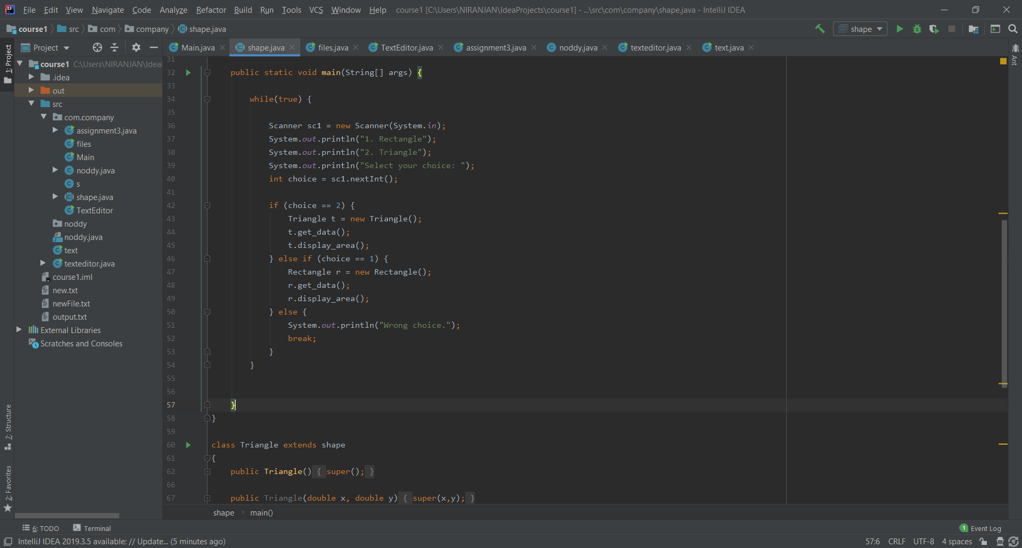

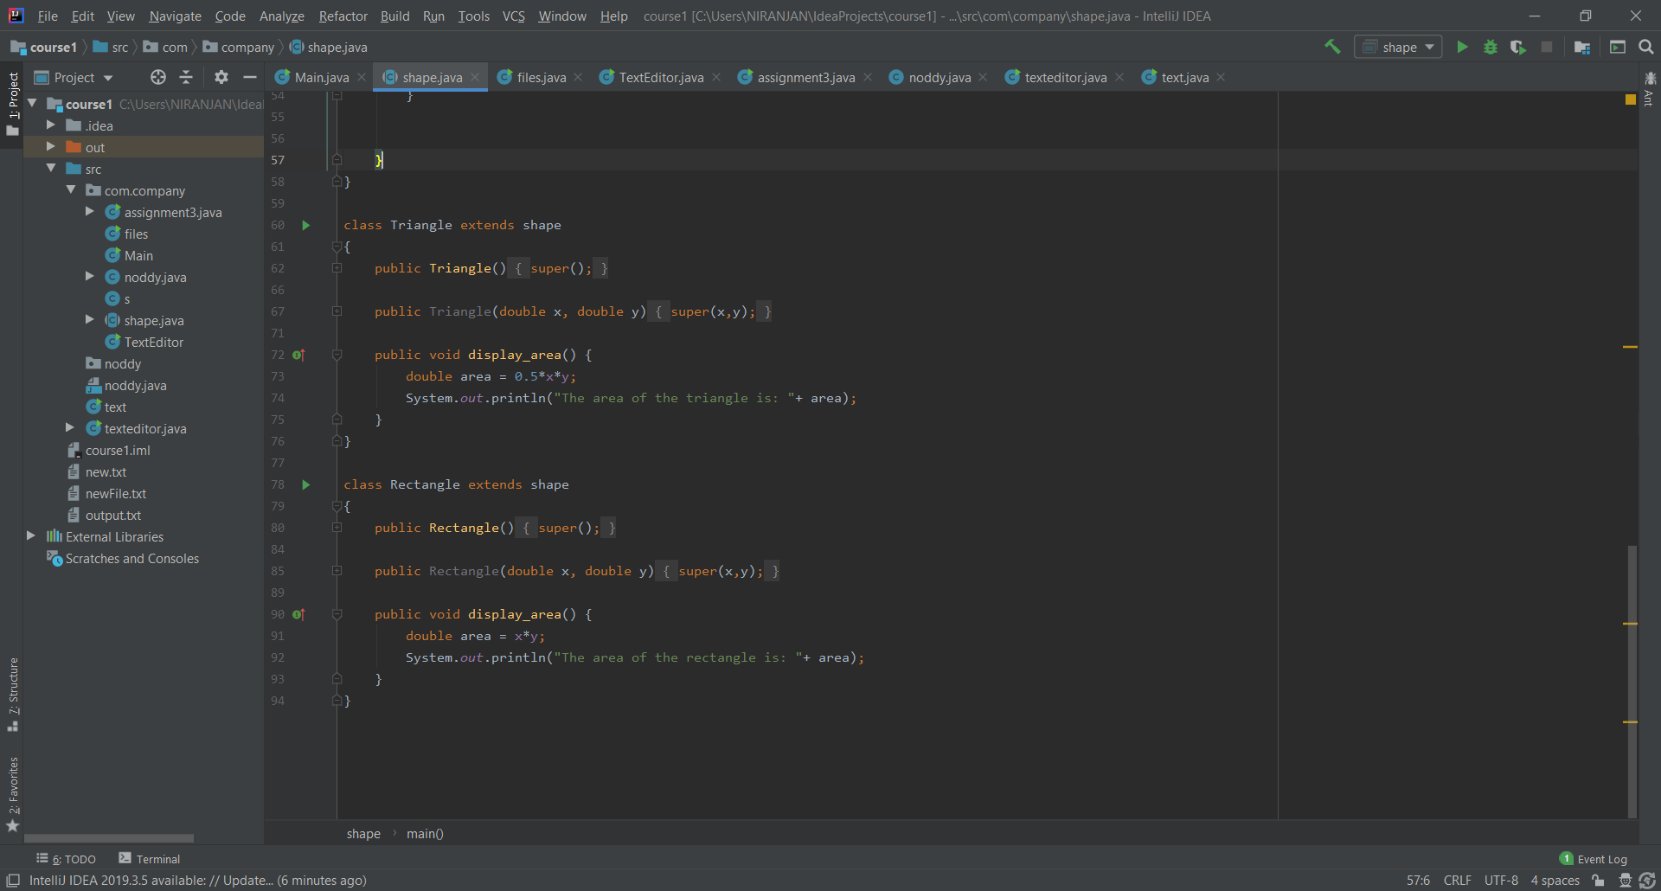

**Output of the Following Program ->**

1. ***Area of the Rectangle ->***

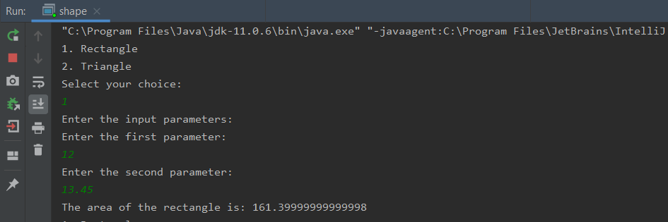

1. ***Area of Triangle ->***

